The Beaufort County Solid Waste Committee met on Thursday, July 2, 2020 at 10:00 AM, in the boardroom located at 136 W. 2nd Street, Washington, NC with the following present:

Committee Members Present:

Commissioner Stan Deatherage, Chairman
Commissioner John Rebholz
Commissioner Frankie Waters

Staff Present:

Brian Alligood, County Manager
Katie Mosher, Clerk to the Board
Christina Smith, Public works Director
Anita Radcliffe, Chief Finance Officer

Commissioner Deatherage called the meeting to order.

Motion: Commissioner Waters motioned to approve the June 2, 2020 meeting minutes. Commissioner Rebholz seconded. The vote was unanimous.

Recycling Update

Ms. Smith said as everyone remembers when we met last month, we had discussion regarding recycling, and it was the recommendation of this committee that we take the recycling discussion to the full Board of Commissioners. She said so when everyone receives their packet from the Clerk for this Month’s Commissioner meeting you will see in this packet information, an agenda item regarding recycling. She said you will see the description where Republic Services will be there to answer additional questions you may have and basically, if you will bear with me, I’m going to read to you what will be presented. She then read the following:

Republic Services currently provides recycling services at all ten collection sites located throughout the county. Recycling is collected in one container and co-mingled. It is then transported by Republic Services to East Carolina Vocation Center (ECVC), a local MRF, or Materials Recovery Facility, located in Greenville to be processed.

As previously discussed, the recycling industry has experienced many changes in the past years. Republic Services received the attached letter from ECVC detailing the increase of their processing fee from $60/ton to $100/ton. The letter also mentions policy changes regarding acceptable materials. Republic Services personnel will answer questions regarding ECVC policies and current/anticipated trends in the recycling industry.

Ms. Smith said this is what we spent quite a bit of time discussing during the last committee meeting. She said I met with both Joe Deer and Chris Wilson with Republic Services on June 17th and we spoke about that as well and Joe was planning to contact the gentlemen that wrote the letter from ECVC, Mr. John Coward, to get further information from him regarding what is contained in the letter talking about material that was no longer desired to be in recycling to see if that was a strict current policy or this letter was just more of what he anticipated to be the policy in the future. She said Joe was not aware of them changing their policy as strict as what this letter made it sound. He said at the time he thought it was just more of where the industry was going and ECVC was saying that if the number of, if the amount of glass and the amount of contaminated recycling was not reduced then they would have to continue increasing your fee which does, of course, make sense because it is a very labor intensive process to take out the recycling that is contaminated. She said one of the things, again, that is a thing that’s changed, the recycling, if it’s not clean, if the cans, if your green bean cans or your tomato sauce cans are not washed out then some people will pull those out and that’s considered to be contaminated so there’s a lot of education that goes along with that. She said so again, at the Commissioners meeting on Monday night Republic Services will be there to hold additional discussions with you about that.

Commissioner Deatherage said let me ask a question if that’s okay. He said I’m going to slow you down a little bit because that was a big part of the last meeting. He said cost was really a factor and the main factor is what they will take. He said are you saying that he was hypothesizing on what may be taken in the future as well as the cost.

Ms. Smith said yes.

Commissioner Deatherage said so we really don’t know what’s going to be taken exactly. He said that could all change because my whole basis for approaching a new recycling plan, which I’m looking to formulate as soon as I know a little bit more, is about what they take and what they won’t take. He said it’s not so much the cost. He said there’s no need to recycle if they won’t take the stuff or they won’t take enough stuff where the public sees no use in recycling. He said that’s the big problem is the public. He said we’ve got to have them on board.

Ms. Smith said and that is what they are planning to come and present to you on Monday evening. She said they will have more specific information about that. She said however, be aware that what they say on Monday night, what they accept this week, the markets change and could change drastically a week from now.

Commissioner Deatherage said but that changes everything on an immediate basis for me because I don’t think we’ve got a lot of time once this recycling ends to keep the public on board, so we’ve got to have a plan. He said that maybe buys a month or 2 to get a plan together so we can be more functional once we go with a plan. He said does that make sense.

Commissioner Rebholz said I’m not sure I understand.

Commissioner Deatherage said my position on recycling is it’s a good thing to do. He said now, if we can’t put enough items in the recycling bins that will be recycled the public is not going to go for that, so it ends, irrespective of the cost. He said my feeling is if we don’t exactly know what they will take and won’t take then there’s going to be a delay in formulating a public plan for recycling.

Commissioner Rebholz said if they come in Monday night and say this letter is what we will do starting July 1st.

Commissioner Deatherage said what Ms. Smith is saying is it could all change in a month or two, anything can change.

Commissioner Rebholz said how do we formulate a plan if everything is changing.

Commissioner Deatherage said you have to be fluid and ready to go. He said even then it would take time. He said my plan is probably going to be comprehensive in such a way that we’re going to have to have some help from the State and federal government and they’re going to have to consider doing it themselves. He said we’ve gone a long way in America recycling. He said I started recycling 4 years ago and I think a lot of other people have been recycling for a long time too. He said my wife, she said it’s going to kill me not to put glass in the container anymore and I said well, that’s the new plan. He said now I’m finding out I can go back and tell my wife you can put glass in the container for another month or 2, right Ms. Smith. He said is that basically what you’re saying.

Ms. Smith said I’ll say for now, yes sir.

Commissioner Deatherage said so breaking it down on that level because that’s the level you appeal to the people on.

Commissioner Rebholz said it says effective July 1st.

Ms. Smith said the City is effective July 1st.

Commissioner Waters said for me, when we say recycle, we need to be recycling. He said the problem we’ve got right now is the public thinks we’re recycling everything that they put in the recycle bin and we might have 70% of it that ends up in the landfill.

Commissioner Deatherage said that would be the new plan, or somewhere close to that.

Commissioner Waters said well, but, if it ends up in the landfill, 70% of it, we need to tell them you can’t recycle those items.

Commissioner Deatherage said we need to decide whether we’re going to recycle if it’s going to be like that. He said I almost feel like if it’s going to be the 30% out there that’s actually going to go to recycling, maybe, and that could change, the 70% we know is probably going to go into the landfill, my opinion is, and the Commissioners can do what they want but we just stop recycling until we know a plan.

Commissioner Waters said I thought that’s what we did at the last meeting. He said we agreed that so much of it is that we weren’t going to recycle.

Commissioner Deatherage said but what I’m gathering from Ms. Smith is we may have a month or 2 delay on that even.

Commissioner Rebholz said I think what Ms. Smith is saying is we don’t know.

Commissioner Deatherage said exactly, we don’t know. He said last meeting we knew something. He said now we don’t know.

Commissioner Rebholz said is ECVC going to be here or just Republic.

Ms. Smith said I have not received confirmation on that yet so I’m not sure. She said we will have answers for you on Monday specifically on what materials are acceptable at ECVC, what’s allowed and what’s not allowed.

Commissioner Deatherage said when you start using the example of cans, that’s one of those nebulous things a lot of the times they won’t take and then they will take some if they’re clean so we’ve got, we need to formulate a lot of questions to get a lot of answers at this public meeting and then, and this is good. He said I’m almost thinking we might need them to come back the next month.

Ms. Smith said it depends on what’s, let’s take Monday night first and see what answers we get on Monday night and go from there because again, ECVC, it’s a large operation. She said if you drive the 264 bypass you see the stockpiled material that’s located there so it’s a large operation and it’s a very manual operation. She said it’s a labor-intensive operation. She said there are machines that do it as well but there’s also a large part that is very labor intensive so it’s not an exact science and it’s not a very clean operation. She said when you have kitchen trash where you’re washing it out and you’re putting it in your recycling container still with water in the containers or cans and it’s not dry then that gets dumped in with the cardboard or your mixed paper and that gets wet and soggy and the paper tears so it’s difficult for them to go through it and pull things out so let’s see how it goes on Monday evening and see what questions are answered. She said we’ll have a specific list that says what they will accept and what they will not accept, if that’s okay and then we will determine if it’s still beneficial to continue.

Mr. Alligood said as I understand it from the last meeting this Committee held, when you made your recommendation to move forward in the next agenda, it was based more, I thought, on the economics.

Commissioner Deatherage said not for me but maybe for the other guys.

Mr. Alligood said that’s just what my understanding was because whether they are going to only recycle glass or whether they’re going to recycle everything that you can possibly recycle, it’s costing you more to recycle than it is to throw it in the landfill at these new prices.

Commissioner Deatherage said yeah, we’re talking a minimum of $8,000 more and it could be more than that.

Mr. Alligood said right, so from a staff perspective, or a financial perspective, or recommendation to you was, and will be you’re spending more money so you should be trying to spend less money. He said the political decision is do you take that additional cost and say its good public policy to do that and I just want to be clear that my understanding from this last meeting was you all we’re looking at the numbers.

Commissioner Deatherage said I’m not looking at just the numbers.

Commissioner Rebholz said I don’t think so. He said for me it’s a combination. He said I think we also came to the conclusion that it would be impossible to educate the public.

Commissioner Deatherage said yeah. He said that’s a lot, that’s a huge undertaking. He said that little bit of money doesn’t bother me. He said we could find that money somewhere else but to stop recycling and then try to get that going again would be impossible or a very tough task. He said lying to the public is even worse so we can’t do that. He said I think most of my questions are going to be geared towards are we going to be able to effectively continue to recycle and can you let us know when we’re not going to be able to do that anymore because what we got from Ms. Smith last month, I don’t even think, you threw out the percentage 30/70 right and I kind of get, that 30/70 sounds about right to me. He said what was being recycled will continue to be recycled and about 70% will go in the landfill. He said that could be 40/60, I don’t know but it sounds a lot like that.

Ms. Smith said I don’t think anyone can really quantify that because you, are you talking about tonnage or are you talking about, you can’t really do that because you’re talking about paper versus glass and glass weighs a lot more than paper so if you continue to recycle paper but you don’t recycle glass your tonnage is going to be a lot higher so you can’t really quantify that.

Commissioner Waters said up to this point have we been surcharged.

Ms. Smith said no.

Commissioner Waters said but they’re putting up the notice as of July 1st that we may end up with a surcharge if it ends up going to the landfill.

Ms. Smith said we have not been hit with a surcharge, but we are paying an increased processing fee, so they haven’t rejected our loads yet that I’m aware of.

Commissioner Waters said but that processing fee can keep going up.

Ms. Smith said yes, but I believe, I guess we, County residents at our collection sites, people that make an effort to separate are doing it strategically so I think perhaps, and also because our collection sites are manned, perhaps our contamination rate is a little lower than some other places so maybe we’re a little better because if you, probably our biggest contamination is there are grocery bags that are thrown in there. She said most people come up and they have their recyclables in those grocery bags because they’ve been saving them until they can take them to the collection sites so I think most people that do it, it’s an effort on their part and they are trying to do the right thing and they separate it. She said so they’re not throwing a lot of trash in there. She said if it is contaminated it’s purely because they’re not educated, and they don’t know. She said it’s probably more that they’re trying to do too much of a good thing so more the most part I don’t think we’ve had any major issues with that. She said but again, we’ve only had 230 tons of recyclables but when you’re looking at tonnage, you’re talking about recyclables which are a lot of water bottles, a lot of soda bottles, which are light materials.

FEMA Reimbursement

Ms. Smith said the next item is the FEMA reimbursement update.

Ms. Radcliffe said yes, it has been received $110,000 and change.

Commissioner Waters said that was for which hurricane.

Ms. Radcliffe said that was for Florence. She said we’ve already received Dorian. She said Dorian was, I believe around $50,000.

Landfill Operations Update

Ms. Smith said if you recall, Tar Landing and Company gave notice that they were not intending to renew their contract. She said due to Covid and due to some other circumstances, David’s Trash Services sub-leased the office area as well as the shop area from Tar Landing and as you’re also aware they are building a new facility in the Industrial Park off of Chery Run Road. She said they have had some delays in the construction of their new building. She said in speaking with Rob Cutrell, as well as David’s Trash Service, it was decided that the what was best was to continue those contracts on a 5-month basis to get them through the construction of their new building. She said it also allows us to get an RFP out and continued operation at the landfill. She said it gives Rob Cutrell additional time to get his equipment and other things removed from the site as well, so those documents have been sent out for signature. She said so again, David’s Trash Service is still on site and operations are still continuing there.

Ransomville Operational Review

Ms. Smith said at the last committee meeting Commissioner Waters had discussion about the Ransomville site. She said he asked me if I would get with Republic Services and have discussion about that because of complaints about people having to climb the steps and see if there was another way that they could dispose of their normal household trash rather than having to go up the steps. She said when I met with Republic on June 17^{th,} we had that discussion and I asked them if they had any suggestions of other ways the site could be laid out. She said we kind of brainstormed about different things and taking away containers and then as we started thinking we realized they’re not steps at the trash compactor, so I’ve got some photographs to show you.

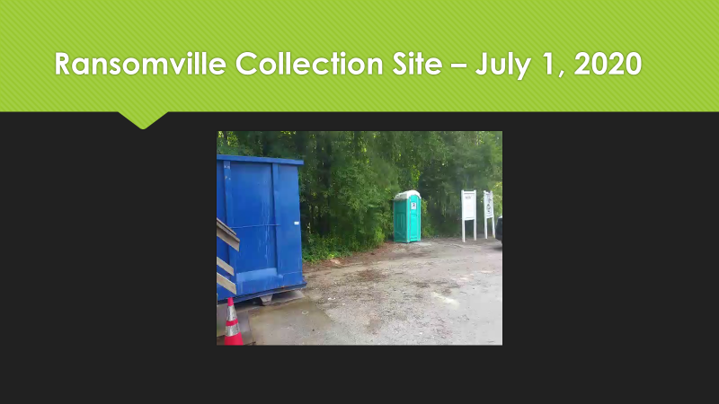

Ms. Smith said this is a view of the Ransomville site. She said the site is shaped like a horseshoe, it’s a one-way site so as you drive in this is the entrance that you see.

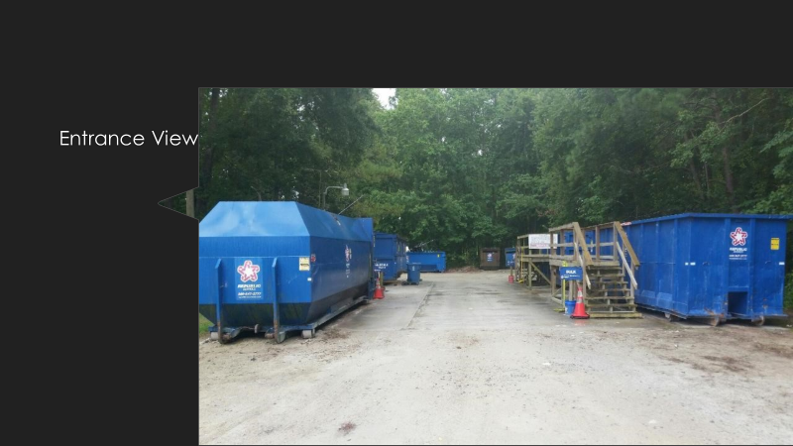

Ms. Smith said on the left-hand side this is the compactor. She said this is the actual compactor, so this is where, typically when you drive up and if you have a kitchen trash bag of waste, typically our white kitchen trash bag, this is where they should go. She said this is where 99% of your standard, municipal solid waste should go. She said so again, you shouldn’t have to climb steps. She said this is where you should be able to just walk up and toss it into the compactor.

Commissioner Waters said so when you go on Monday morning and the orange cones are in front and it’s full and the guy says put it in the other one.

Ms. Smith said that’s what we don’t understand. She said we’re going to have to work on that. She said if it’s Monday morning that it is full then we’re going to have to work on that. She said that should be a timing thing because that should not be the case. She said and if that’s the case, and again, it’s timing as to when they are emptying it because normally they try to empty all the sites in preparation for the weekend. She said but I find it hard to believe that this site is full just from the weekend. She said we will look at the numbers when we get down to that slide. She said the other thing I wanted to say about these pictures is that these pictures were taken yesterday afternoon and there was no advance warning given to anyone so the site attendants at this site do a really good job of keeping everything nice and clean. She said but again, 99% of the time they should just be able to toss it in. She said now, at one time, and I had this discussion with Republic on the 17th, there was something that was special about this compactor and what they were doing was when it needed to be emptied they were taking the container back to the transfer station and they were not bringing another container and when I talked with the operations manager he said he was going to have discussions with them about that and they were going to start bringing another smaller container and leaving it there so that would not happen again. She said still, the amount of traffic this site gets I just can’t imagine it being that big of an issue. She said they should just be able to put it on the ground, but again, if it’s a Monday morning issue that is something we should be able to address.

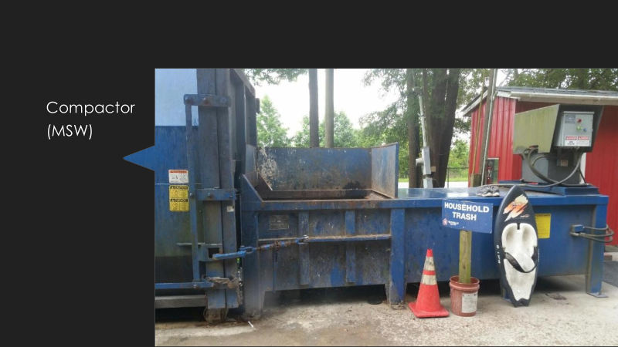

Ms. Smith said this is the recycling container. She said you see the doors where you can just slide the doors off to the side. She said you just slide the doors open so you can toss in your recycling. She said I guess they’ve got the little pallets there so people are able to reach that. She said I can see how that might be an issue for not a very tall person so I could see that being a challenge.

Commissioner Waters said there’s no steps there.

Ms. Smith said there’s no steps there, it’s at ground level. She said there are a lot of counties where this is what all collection sites do. She said Bertie County, every single site is like this. She said Craven County, all the sites are on the ground. She said this is where their containers are.

Commissioner Rebholz said the closest one in Craven doesn’t even have bulk. He said is the big problem the bulk at Ransomville.

Commissioner Waters said when she gets to it you will see.

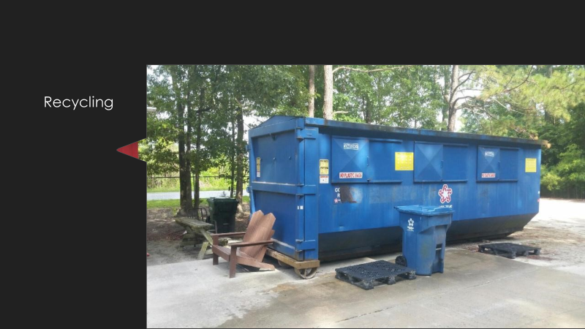
Ms. Smith said so this is the bulk waste. She said this has steps and so it depends on what it is that you’re taking in there.

Commissioner Rebholz said Ransomville, in terms of tonnage and loads and bulk is really low.

Ms. Smith said that’s right and that’s because most people that have something that is large, they don’t take it here because they have the steps so they just continue down 264 or they take it to Beach Ridge which has a mounded site. She said they take it somewhere where it’s easier to off load it.

Commissioner Waters said does Republic suggest we just take the steps away or that they take the steps away.

Ms. Smith said Republic will do whatever we want them to do and these are all there because in the past the Commissioners said give them everything that they want. She said they didn’t want anyone to complain that “I have less service than this person has”. She said in my opinion that’s how we’ve gotten into the situation that we’re in. She said I believe we’ve spread the services to thin and the quality has dropped. She said that’s why my opinion is that we should decrease the number of collection sites and improve the quality of our service.

Mr. Alligood said Commissioner Waters, when you said the steps do you mean just the steps or the container.

Commissioner Waters said I’m talking about the steps going up there. He said the complaints that I get is the old people that go, we can believe them or not believe them, when the compactor is full these are people that say the compactor is full and they’ve got to walk up those steps, which is very dangerous, with a bag full, out of the kitchen, and throw it in.

Mr. Alligood said then I don’t think you would want just an open top if that’s the case. He said if you have an open top you’ve pretty much got to have steps so people can walk up. He said otherwise you’ve got people swinging them over the top.

Commissioner Rebholz said Craven doesn’t have steps.

Mr. Alligood said then I’m guessing there’s a lot of trash around the containers.

Commissioner Rebholz said they’re not as high. He said they’re about 2/3’s as high.

Commissioner Waters said but we’ve got 2 open containers there with 2 steps. He said one to each of them.

Ms. Smith said yes. She said one is for bulk waste and one is for yard waste.

Mr. Alligood said the issue is that they are detaching the container from the compactor and then not dropping another on that can be attached to the compactor. He said that’s an operational issue. He said they can fix that pretty easily.

Ms. Smith said that’s what I talked with Joe about.

Mr. Alligood said why would you take it all the way back to Washington and say, not leave one. He said every other place would detach it from the compactor and leave another one in place and you never have a delay. He said why would you not do the exact same thing. He said that doesn’t make any sense.

Ms. Smith said they said the compactor, the way it was designed, there is a certain container that will attach to that compactor. She said I’m not justifying it. She said it was something I talked to them about that they were going to address. She said that part will be taken care of.

Commissioner Waters said every complaint I’ve had was that the compactor was full and the only issue so if they’re solving that then that’s fine, I’m satisfied.

Commissioner Deatherage said that still is a workable solution for a lot of people into their 70’s and some people not so much. He said I hate to take away from those people who can go up those steps and throw stuff in, in case the compactor, on the off chance that it’s not functional. He said on the other hand I can’t see us mounding it up and making it perfect. He said that would be a lot of money. He said here at least we have a place close by where they could go up the steps and throw stuff in, if, in the off chance the compactor is full.

Mr. Alligood said that’s not where people need to be throwing household waste anyway. He said that’s for bulk trash.

Commissioner Deatherage said yes, bulk, that’s what I’m talking about.

Mr. Alligood said from that perspective, if your concerned about the steps what Commissioner Rebholz suggested is have Republic bring in the shorter sided containers. He said then you would pretty much eliminate the falls.

Commissioner Waters said the people who are bringing in stuff on a trailer or a truck are not going here anymore. He said they’re going to Yatesville. He said I think that’s what we’re seeing.

Mr. Alligood said but getting back to what Ms. Smith’s original statement was, we’ve tried to be as accommodating at every site that we have. He said if you want to continue to be as accommodating as you can at every site then have Republic bring in a short-sided container. He said otherwise look at the volume and say just go on down the road and do away with it.

Commissioner Deatherage said I’ve got a question. He said can they throw MSW in there. He said is that okay to throw MSW in there.

Ms. Smith said sure you can but you’re losing your efficiency.

Commissioner Deatherage said we’re already losing our efficiency.

Ms. Smith said we’re losing our efficiency, we’re spending money. She said that’s the reason we formed this committee is because the cost of solid waste is more than, it just keeps increasing and we’re trying to find a cost savings.

Commissioner Deatherage said let me ask another question.

Ms. Smith said can I finish my answer.

Commissioner Deatherage said I’ve got your answer.

Ms. Smith said no, not yet. She said you can throw MSW in that container because you know what happens at the transfer station, the compactor waste and the bulk waste all gets dumped in the same pile but the reason you put the two separate is for efficiencies when you’re hauling. She said because when you put the MSW in the compactor and they’re trucking it all the way from Ransomville to the transfer station, which is at least a 45 to 50-minute haul, one way, they’re taking 3 or 4 times the amount of waste. She said that bulk waste, if you go back and look at the spreadsheet I gave you 3 months ago, that’s what’s costing us so much money. She said we need to reduce the bulk waste that we are collecting.

Commissioner Deatherage said I agree with that.

Ms. Smith said so that container has void after void. She said if we make that a smaller, lower container all we’re doing is that truck going down 264, he may as well be throwing dollar bills out the window as he goes.

Commissioner Deatherage said let me run this by you since we’re in that vein of thought. He said wouldn’t the steps there, and from what I heard you say earlier, wouldn’t the steps there be a deterrent to MSW going in that container.

Ms. Smith said people will still throw in MSW.

Commissioner Deatherage said well there you go. He said that’s a thought, I’m just throwing that out there.

Mr. Alligood said from what I’m hearing the operational folks say, they want you to put everything you can in the compactor. He said even some of the bulk stuff they’re saying ought to go in there. He said the compactor will tear it all to pieces. He said I think there are certain things you don’t want going in there but their comment was you put everything you can in the compactor.

Ms. Smith said anything that fits in that hole needs to go on in there. She said if it’s a barbie doll house, if it’s a dining room chair, it will crush it and crunch it and it will go in there. She said as much as you can get in there needs to go in there because again, when it gets to the transfer station it all gets dumped on the same pile and then you’ve got dozers and everything mixing it all up together to get pre-processed before it goes to the landfill in Bertie County.

Commissioner Waters said if you’ve got low tonnage going out of there and you’ve got 2 of these, I mean, do you need 2 of the big bulk containers. He said because I’m assuming when you’ve got 2 what keeps people from trying to fill up one. He said when they’re coming in people are filling up both of them.

Ms. Smith said there’s only 1 bulk.

Commissioner Waters said oh, I though there were 2. He said what is the next one.

Ms. Smith said the next one is vegetative.

Commissioner Waters said is there steps on #2.

Ms. Smith said yes but not many people use that because they will go where they can just sweep it out the back of their truck.

Commissioner Waters said this is the cleanest site I’ve ever been to.

Mr. Alligood said your comment about the folks with large stuff moving on down the road to a site that’s mounded. He said if you did away with that and folks still had the barbie doll houses and other stuff, they can go in the compactor and I don’t know that you would necessarily lose, what I think I heard you say is folks who’ve got great big stuff aren’t going there anyway so the stuff that we’re seeing could go in the compactor and you probably wouldn’t miss that because people are bypassing it anyway.

Commissioner Waters said did they suggest removing those.

Ms. Smith said no. She said they’re not going to suggest removing anything. She said the more, they’re paid to man the sites, they’re paid to haul the debris, they’re paid to dispose of the debris.

Commissioner Waters said are you saying that maybe we should consider asking them.

Mr. Alligood said what I’m hearing you say is that people are telling you they’re not taking their big bulk stuff there anyway. He said they’re going on down to Yatesville. He said it makes sense. He said I would much rather push it over the side than lift it up and over so the great big stuff, if it’s already bypassing that site, the other remaining stuff probably can go in the compactor. He said I guess you could pull it out of there and see.

Commissioner Deatherage said is that a compactor and you dump it over, not like the other sites where you just let it fall over because you’ve got a mound. He said is that a compactor.

Ms. Smith said all the sites have compactors.

Commissioner Deatherage said but when they do that, when they say I’m used to doing it this way, it’s easy for me to do it and just load it off.

Mr. Alligood said not in the bulk container.

Commissioner Deatherage said it’s not a compactor.

Mr. Alligood said at the mounded sites you do have a compactor and trash goes down a shoot because they’re up but the bulk, they don’t have a compactor.

Commissioner Deatherage said it seems like you could figure out a way, and I guess you’ve already have but move everybody towards the compactor, keep the compactors running efficiently and if you’ve got to have steps then have steps because that’s a deterrent for keeping people from using them unless they absolutely have to. He said I haven’t had a complaint.

Commissioner Waters said from an operational standpoint the complaints, they’re going to settle the problems and complaints that I get.

Ms. Smith said I think so. She said the main thing is the compactor. She said again, this is a small site so it’s easy to look at the numbers but again what I would challenge you to do, and something that we’ve all talked about and something, I was going to discuss it later but I really think we need to take a long hard look at making some operational changes at many of the different convenience sites and changing, perhaps, how we do things. She said maybe reducing services, maybe reducing hours and my suggestion would be not picking and choosing today and then picking another site 2 months from now but let’s look at a strategic plan and have it all in there together and my suggestion is doing something similar to that where perhaps you do reduce services at some sites and provide better services at some of the other sites. She said if you have to throw away a sofa or mattress perhaps you do have to drive a little farther but it’s a little easier for you. She said you don’t have to manage steps to throw away a sofa or something along those lines. She said I think your immediate problem, Republic Services will solve it. She said since we’re here we’ll just continue going through the pictures.

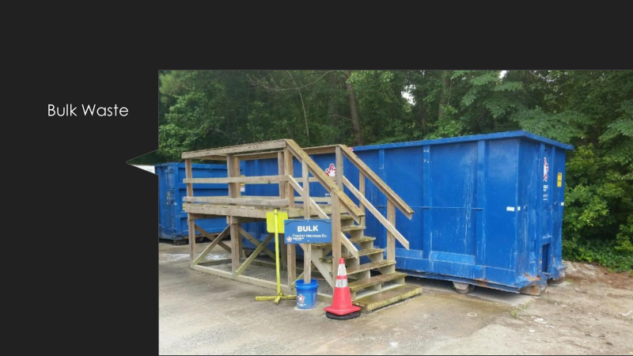

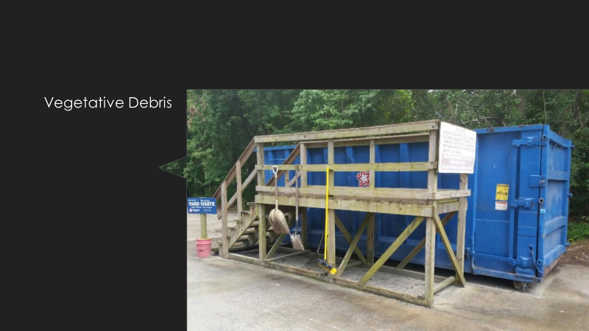
Ms. Smith said here’s your used oil.

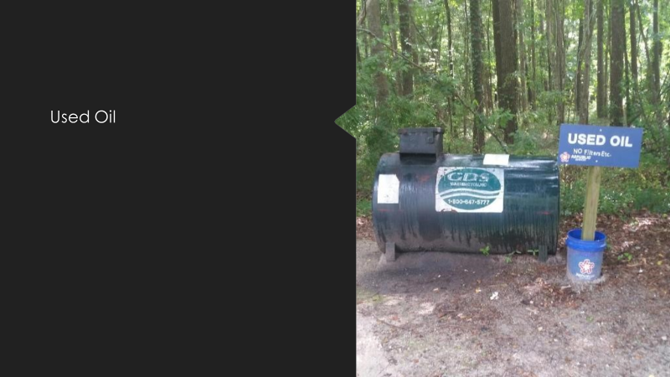

Ms. Smith said next is white good and metal. She said this is also something that, again, trying to solve a problem, previously we only took metal at certain sites but then metal was getting thrown into the bulk and increasing the tonnage so, trying to work around that, and anyway, right now they do have this and people just toss stuff in but as you can see this is a lower container.

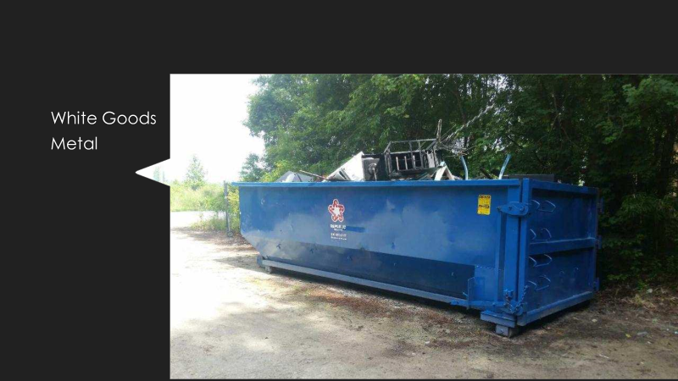

Ms. Smith said then they also do have cardboard. She said even though we say we take co-mingled recycling, we do, you can throw cardboard into the regular recycling, which is a little odd to me and I’ve actually discussed that at length with Republic because the other recycling is so wet but they do accept wet cardboard. She said what Nicky found, who is the operations manager here in Beaufort County, is that the cardboard gets in the bins and it just creates voids and makes it difficult to mix in with the others so he brought in these containers that are nothing but cardboard. She said he has a truck that goes around and runs those, so he does have cardboard and with the prevalence of on-line shopping so, a lot of the sites now have these cardboard containers and people do use those quite a bit. She said you just slid it in the slots and it’s pretty easy and keeps everything dry.

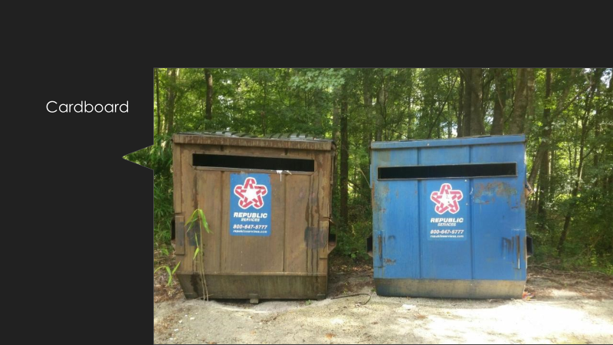

Ms. Smith said this is the chart that Commissioner Rebholz, I think he had, so again, if you’re looking at Ransomville, I had the numbers across the top but across the bottom you will see that Ransomville represents only 3% of the hauls from 2019. She said for MSW it’s 9% of the tons. She said 1% of the bulk tons. She said interestingly they’re 10% of the recycling. She said vegetative 1% and metal goods and white goods, 8%. She said so when you look at the overall MSW, it’s not very high and neither is the bulk so if you remove that bulk container I don’t think it’s going to be a great loss because people don’t use it because they go to the mounded site. She said same with vegetative, if they want to do that they go to a mounded site.

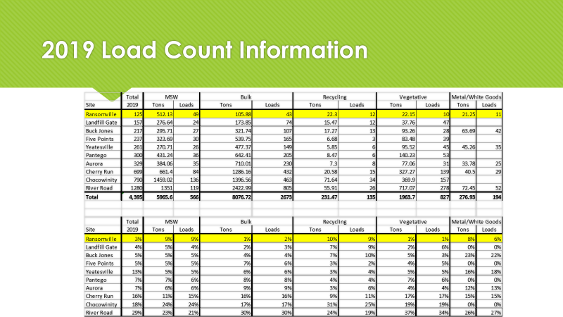

Commissioner Rebholz said so how do we move forward on a strategic plan. He said what are your suggestions.

Mr. Alligood said you’ve got the study, that’s a good start. He said you’ve just got to go through that and decide how you’re going to move forward. He said are you willing to decrease services because that’s essentially what this is. He said you are going to decrease services and put services in a more strategically located place.

Commissioner Rebholz said but we’re also not going to continue to raise the fees.

Mr. Alligood said I hope not. He said remember though, the volume is going to be the same, so you’ve got to squeak out some money somewhere. He said I don’t know where it’s all coming from but if you look year to year it is just crazy how much it’s gone up.

Commissioner Waters said Monday morning, it was actually Monday afternoon at Beach Ridge, the compactor was full, the bulk was full because that’s where they were throwing everything. He said there were 2 bulk containers there. He said one of them was full of construction items and I’m telling you there were shingles in it and that is the first time I’ve seen shingles in one.

Ms. Smith said it is illegal to throw shingles in the dump.

Commissioner Waters said here again, unless you can regulate, I mean the employees that are there, if they’re watching TV or asleep in their little hut and nobody knocks on the door, they’re just going to keep on unloading until somebody tells them otherwise. He said the guy that was running it Monday said 2 weeks ago he had somebody come in and they had 11 of these contractor bags and he said he noticed that it took 2 people to remove the first contractor bags and throw them in. He said he told the guys wait a minute, he went over and he opened the bags and guess what they had inside of it, shingles.

Commissioner Rebholz said you know what, you just found the solution. He said we’ll take all the bulk containers and make them have steps.

Commissioner Waters said I think all the bulk containers need to be in a location that’s far enough, the problem is we’ve got contractors that are not using David’s or Republics contractor bins and taking them to the site.

Commissioner Deatherage said well shingles aren’t supposed to go in there anyway.

Commissioner Waters said that’s right. He said but we’ve got contractors that are probably charging the customer so much for dumping but they’re taking it to our sites.

Commissioner Rebholz said so how do we go forward to come up with a plan.

Commissioner Wates said as long as there’s a container at Beach Ridge or Yatesville where somebody can back up to it, we will never eliminate that problem. He said they’re going to take it and put it in there.

Commissioner Deatherage said I think we should raise them all up high and put steps. He said they’ll just keep moving on or else they’ll have to have a lot of strong people and then you catch them.

Commissioner Waters said here again, every site is operated a little different and each site is operated different based on the employee that’s there that particular day because I took a telephone call last week on the Beach Ridge site. He said they were rejected. He said they had construction items in the back of a pickup truck, and I asked them were you pulling a trailer and they said no. He said I was hoping they would say yes because I was going to ask them if it was a dual axle but he said no and that guy who is running it, you know he’s very thorough, and he’s strong enough, he’s an ex-marine, he just will say no but if you get the lady that’s in there working one day, I can tell you she’s not going to confront somebody. He said she’s just going to let them do it.

Mr. Alligood said it’s my understanding that was an appropriate rejection because that guy was rehabbing a kitchen in a rental property and he owns property in Beaufort County, but he lives in Craven County and he was rehabbing a kitchen in a rental property and that’s commercial. He said so it was an appropriate rejection. He said now he doesn’t think that because he owns property in Beaufort County, and he pays the fee. He said but you’re making money off that property which makes it commercial.

Commissioner Waters said but if he had done that on a Saturday morning there would’ve been nothing said. He said he would’ve just backed up there and dumped it. He said that’s the point I’m making is that every site, we’ve got problems on certain days of the week and we’re never solving that unless you remove the opportunity for the contractor to dump stuff.

Mr. Alligood said the contractors that have been around long enough know the sites, they know who’s working where and that’s when they make their trips so they can get rid of what they want to get rid of.

Ms. Smith said it’s surrounding counties as well so with a fee you either have to eliminate the problem or you have to charge to cover it and that’s where the rub comes. She said we’ve had this discussion for many years. She said we’ve had discussions about tag programs, sticker programs, there are pluses and minuses, pros and cons for all of them but something needs to, we need, in my opinion something has to change. She said whether it is increasing the fees, or something has to change because we can’t keep going down the path we’re on.

Commissioner Waters said I think we missed the opportunity when we had the tax payer, even though they live in Craven County, come over and experience what they did last week without the employee having the sheet of paper that Republic or Beaufort County has done that says we will honor this today, you can put it in there but if you come back next time we expect you to go rent a container or take it to the transfer station. He said the educational part we keep talking about.

Commissioner Deatherage said refresh my mind on this, the sticker program. He said what are the reasons not to do it.

Ms. Smith said a lot of the cons with the sticker program are if you put it on the car what happens if you trade the car or if you sell the car, do you only get one sticker per parcel then what happens if it’s on the pickup truck and you have to drive the car that day to throw away the bag of trash. She said if you put a hanger on the mirror you could give it to someone else.

Commissioner Deatherage said a card is the same way.

Ms. Smith said there are a lot of things that were brought up. She said then there was the discussion on the bags. She said you purchase orange bags from the convenience stores and you only accept trash in those bags or you have stickers where you purchase stickers from the grocery stores and the bags have to have the sticker on it in order for us to accept it.

Commissioner Deatherage said I’ve got a hybrid here. He said is there any way we can buy bags and distribute those bags to people, and they get only X amount of bags.

Ms. Smith said sure, you can do that but then you’ve got the question of what do you do with the bulk.

Commissioner Deatherage said that’s a whole other kettle of fish. He said that’s a truck, usually, on the bulk. He said they can put that sticker on the truck and sell that truck, they better find another truck with that sticker on it or petition for another sticker from the County and make them pay for it.

Ms. Smith said there are lots of programs but there are a lot of support costs that go along with that.

Mr. Alligood said with all do respect, it’s whatever the Board decides they can live with. He said you can put in what ever control measures you want but if the Board isn’t able to say that’s what we’re going to do without exceptions then it won’t get done.

Commissioner Deatherage said you’ve almost got to do no acceptations. He said I would almost agree with Commissioner Waters “just this one time, but don’t do it again”. He said you’ve got to have some control measures so they can’t do it again. He said that’s where I’m starting to spit ball on the sticker program again. He said kind of a pay as you throw method.

Mr. Alligood said it’s my understanding that there is other countries where you have to buy clear plastic bags and you put it on a scale before it goes in and you pay for that. He said they’re that strict on it. He said we’re not that way.

Commissioner Deatherage said Commissioner Richardson is here today has a more draconian plan than that, he says put a tax on everything you buy and that’s not a bad plan either. He said how much can you take from the public. He said that’s what it’s going to come down to, how much guff can you take from the public. He said if you put together a really good plan and sell it and stick to it you might just have something here.

Commissioner Rebholz said it’s my understanding that’s what this committee is supposed to do.

Commissioner Deatherage said well it’s really going to come down to the Commissioners though.

Commissioner Waters said what we’re doing now is we’re taking the stuff from the taxpayer and we’re just increasing our tonnage and we’re having to increase the fee to take care of it. He said that’s it in a nutshell.

Commissioner Deatherage said and we’re really not accomplishing the problem, we’re just making it work.

Commissioner Rebholz said 85% of our tonnage is in MSW and bulk. He said so the recycling, white good and the vegetation all together counts as 15%. He said I don’t know why we need to do that at every location. He said why do we do white goods at every location.

Commissioner Waters said we have the building contractors but on the other side we have the landscapers and the tree people. He said most of the tree companies have the grinders on sight but they’re the 2 that go in with the trailers and fill them up.

Commissioner Deatherage said yeah, we don’t need that. He said I don’t like that. He said that’s the most recyclable thing we have, yard waste. He said there’s got to be a better way than that. He said that stuff breaks down on its own and creates very nice dirt.

Commissioner Waters said Ms. Smith, after a long discussion I think you’ve settled the problem there, that every time it comes up, I’m trying to educate people. He said I had a guy tell me the other day that he had loaned somebody his tractor and a front end loader and his truck to clean up building material that had been piled up and he told him you either take it to the Pantego site or the Yatesville site and he happened to call me first to ask if that was okay. He said I said no, they’re going to turn you down. He said I told him you’ve got to rent a contractor’s container and take it to the site and then you can take the front-end loader and fill that up. He said most of it is education. He said it’s the surprise when folks get there and get rejected. He said if they’re told in advance by everybody, whether it’s one of us or whoever, they’re not as upset.

Ms. Smith said and also when I met with Republic, we talked about erecting new signage at all of the sites that says very clearly what is accepted and what is not accepted. She said no construction or demolition debris. She said they try to be accommodating. She said if you have a little of this or a little of that, but again, people take advantage of it. She said it goes back to the people are accustomed to taking whatever they have to the convenience sites and we just can’t allow that. She said the bulk, the tonnage of the bulk shows that. She said it’s in the numbers.

Commissioner Deatherage said once we get a plan and we’re going to stand by it, and there’s the education component, I really want your group to be extremely efficient with the website and have space dedicated to all the information and that information needs to be updated regularly. He said it won’t take any time to do that. He said you’ve got a good program and it’s going to work well in that regard. He said I really want to see that happen.

Ms. Smith said that will absolutely happen. She said it’s getting the plans.

Commissioner Deatherage said getting the plans, you need a plan as a platform and any changes need to be from that platform and move up from the plan and all the Commissioners need to be on the same page. He said the Commissioners need to, the public needs to be educated as to where it is on the website and the Commissioners need to be educated as well so they know what the plan is, and they need to stick with it.

Ms. Smith said in an effort to move forward, daylight savings time ends November 1st. She said the Board of Commissioners meet on October, would it be acceptable if I put together, maybe a phase I, a preliminary plan of some minor changes to kind of start. She said perhaps a reduction in hours or things that can be presented. She said most notably, reducing the hours due to daylight savings time ending on November 1 and I present that to this committee and then the plan will be to present it to the full Board of Commissioners at the October meeting. She said do you know when that is Ms. Mosher.

Ms. Mosher said October 5th.

Mr. Alligood said can I just say something. He said you would need to get signage up at the sites in less than 30 days. He said it might be better to do it in September.

Ms. Smith said I’m not sure I could do it by September

Mr. Alligood said you’re talking about reducing hours at sites.

Ms. Smith said more than half of them, yes. She said I don’t think the hours are going to be that big a deal. She said I would have to present it to the Solid Waste Committee before the Commissioners meeting. She said at our next meeting I’ll have something, at least the first phase.

Ms. Smith said the next item on the agenda is the August 2020 full Board presentation. She said this is the one where Republic Services will be coming to give a presentation regarding the curbside or roadside pick-up. She said it will be the PowerPoint presentation they gave to the Solid Waste Committee a few months ago. She said Mr. Alligood sent out the public notice last week or the week before.

Mr. Alligood said it went out last week. He said by statute, any time you have that discussion it has to be run in the paper in general circulation once a week for four weeks and there’s some language in there about sending certified letters, so we’ve sent those out as well. He said those had to be sent to anyone registered with the Clerk and we didn’t have any of those but just to be safe we sent letter to the companies we knew about. He said that ad ran yesterday, and it will run once a week for 4 weeks to cover the statutory requirements.

Ms. Smith said there are currently 3 residential haulers that operate in Beaufort County. She said those 3 are David’s Trash Service, Family Sanitation, and GFL. She said those 3 entities were sent certified letters. She said one additional item that I would like to add to the agenda is from Ms. Radcliffe. She said it’s fiscal year 19/20 financial update, if that is acceptable.

Mr. Alligood said I had a conversation and we talked about this a little bit. He said under a potential plan of moving to curbside you would be displacing current private haulers and that’s why the statute is the way it is. He said the reason you would be is you would be modifying the existing contract. He said I’ve asked the County Attorney to look at that contract. He said my hope is that he will have some information at that meeting to say here’s how I think you can do it. He said the best way you could do that is by RFP, to put it out and say our goal is to move to a curbside, if that’s where you want to go. He said ultimately the best way to do that is through an RFP instead of a negotiation. He said Mr. Francisco is looking at that and I think you’re still going to have hauling costs. He said if you’re going to take and RFP this thing the ultimate winner of the RFP would still have to take it to the transfer station. He said you currently have a contract with Republic to take it from the transfer station to Bertie County. He said it’s not like the RFP winner would take it directly to Bertie. He said that wouldn’t make any sense. He said you would still have some, maybe one or 2 convenient sites that will need to be hauled. He said so Mr. Francisco has to figure that out. He said I think the most appropriate way to do that is by RFP. He said can we legally do that with that contract in place, that’s what Mr. Francisco has to figure out. He said I think we can but I’m not an attorney. He said so once those are looked at, I think what you should say as a group is if you can RFP you should RFP. He said it just makes sense.

Commissioner Rebholz said yes. He said using Commissioner Deatherages hybrid, you wouldn’t necessarily have to have just one hauler.

Mr. Alligood said I think you would want one main hauler. He said you could allow that hauler to subcontract but you would want one hauler because you would want to be able to say to them “you are responsible, you are the responsible party and you’re going to handle all this”. He said you don’t want to have to call different people. He said do you know what I mean.

Commissioner Rebholz said well, no, not necessarily. He said you could have someone on the south side and someone else on the north side. He said why would you want to point fingers.

Commissioner Deatherage said they would. He said they could point and say “it’s his fault” or “it’s their fault” if something goes wrong, that kind of thing.

Mr. Alligood said yes, you could split the County in half, you could split it quarterly. He said I think that’s probably not the way you want to do it because the more numbers you have the greater the efficiency and you want to look for efficiencies but we will certainly do what you all want to do.

Ms. Smith said it would be more like the people on one side would say that their hauler is not as good as the hauler on the other side.

Commissioner Deatherage said in some regards that would be good. He said you’d have the competitive factor ongoing moving forward.

Commissioner Rebholz said I’m just not a big fan of displacing a business when they’re already in existence.

Commissioner Deatherage said I’m not either. He said I’m okay. He said it would be more work for the County, but it would still be better to have an ongoing competitive situation if we did go in that direction.

Mr. Alligood said in that perspective, if that is your concern, you already have that with the contract. He said that model is in play right now. If you want curbside you pay for it.

Commissioner Rebholz said my motivation for curbside is different than that.

Mr. Alligood said that is why we have been very clear, we’ve emphasized and try to be very clear with Republic, don’t tell us in to much detail what your numbers are or what you think you’re numbers are going to be because you don’t want, we don’t want you to come back and say oh, that’s not fair. He said we’ve tried to project that and say don’t get down to the penny on this thing and announce it publicly because you may not be the one that does this. He said we don’t know that yet.

Ms. Radcliffe said I’m going to be really brief this morning. She said this is a year to date actual report as of June 30th. She said I just wanted to give you an update on where I believe Solid Waste will end up for this fiscal year last year. She said you will see some penciled in numbers, estimates on there. She said I think revenues and expenditures will be at year end and if you go to the second page you see that we budgeted $3.751 million revenues and I believe they will come in at $3.871 million so we’re it’s still $100,000 over what we budgeted there. She said then the expenditure side we’re still budgeted the same amount, $3.751 million and I believe expenditures will come in at $3.618 million so we will add, I believe, to fund balance for last year. She said about $229,000. She said don’t get to excited about that because $100,000 of that is reimbursement from FEMA. She said some of that is applicable to hurricanes, last years hurricanes so all in all our current fund balance is $21,335 and once we add that $229,000 to it, I’m estimating a fund balance of about $2551,000.

Commissioner Deatherage said in the enterprise fund.

Ms. Radcliffe said yes, in the enterprise fund. She said we need every dime of that right now. She said we did very little maintenance last year. She said we also had some debt services budgeted for some improvements at the Ransomville site that we did not do once the committee was set up, you decided to put that on hold so that money was spent on tonnage. She said so I just don’t want you to get to excited about adding the $229,000 to fund balance because there were specific reasons that happened last year, like the FEMA reimbursement. She said that was a one time, hopefully, reimbursement thing. She said and then the debt service on the Ransomville site. She said we didn’t end up doing that debt service.

Commissioner Deatherage asked if there was anything else.

Ms. Mosher said the next meeting is August 6, 2020 at 10:00 AM.

Motion: Commissioner Waters motioned to adjourn. Commissioner Rebholz seconded. The vote was unanimous.

Adjourned at 11:38 AM.

Respectfully submitted by:

Kathleen Mosher, CMC, NCCCC
Clerk to the Board

